Yemi Adebanjo
Student ID: 12
CI128: Introduction to Games Development
University of Brighton

The game is to act as a combination of the “Space Invaders” and “Pac-Man” arcade games, in the sense that it will take place in outer space, where the player will have to control a virtual “ship” in order to shoot down aliens and meteorites. The aliens will move to the left and to the right randomly, in order to give the game a sense of challenge. The game will only contain one level.

Most of the game’s assets will be created by me; the player, the aliens, the coin and the meteorites will all be represented in-game as 2-dimensional pixel art, in order to emulate the visual style of the original 1970s arcade game. The software I will be using to make this game is an online sprite editor called Piskel, which can be used to create static and/or animated sprites. All of the game’s visual assets will be saved as PNG files.

The main objective of the game is to avoid the game’s enemies and obstacles and acquire a collectable item at the top of the game’s screen; if the player manages to accomplish this, then the game will end with a message congratulating the player and giving them a final score. Dialogue that either commends or chastises the player will often appear in the Linux command line.

The game will feature walls that are composed of small, 2-dimensional squares; if the player comes into contact with a wall, then the player’s movement will immediately come to a stop; depending on whether the wall is placed in a horizontal or vertical position, the player will either be unable to move any further in a particular direction.

The player will start the game with a pre-determined amount of lives, and if the player gets hit by an enemy, then the total amount of lives will decrease by one. If the player gets hit while they have zero lives, then the game will end.

The game will be windowed only, and its graphics will be displayed in “HD Ready” resolution, or 720p(1280×720).
The game will be developed over a peroid of of four months, between January 2017 and May 2017.

Music and sound effects for the game will be futuristic in tone, in order to have it connected to the game itself in terms of tone and structure. Audio files will have to be open-source in nature, due to an inability to pay licensing fees to specific companies. All of the music files successfully implemented into the game will be saved as MP3 or WAV files and will be downloaded from a website known as The Free Music Archive.

Prototype Screens

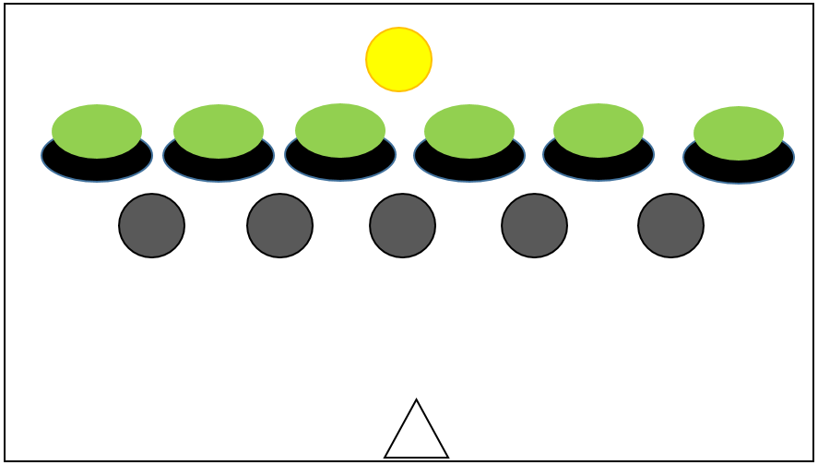
Coin
Aliens
Meteor/Asteroid
Player

You’re doing good!
You just shot an alien! Take that!
Your spaceship has collided with a meteor! Oh no!
You have collected the golden coin! You win!
The aliens have taken you hostage!

Player

YOU WIN!
“You Win” message

Projectile

YOU LOSE…
Try again… if you dare!
Y/N

“You Lose! Message

Gantt Chart
